# CS 305 Module Two Coding Assignment Template

## Instructions

Replace the bracketed text with the relevant information in your own words. If you choose to include images or supporting materials, make certain to insert them in all the relevant locations in the document.

## Run Dependency Check

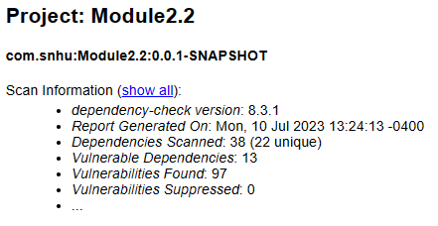

## Document Results

hibernate-validator-6.0.18.Final.jar

Hibernate's Bean Validation (JSR-380) reference implementation.

jackson-databind-2.10.2.jar

General data-binding functionality for Jackson: works on core streaming API

log4j-api-2.12.1.jar

The Apache Log4j API

logback-core-1.2.3.jar

logback-core module

mongo-java-driver-2.4.jar

Java Driver for MongoDB

snakeyaml-1.25.jar

YAML 1.1 parser and emitter for Java

spring-boot-2.2.4.RELEASE.jar

Spring Boot

spring-boot-starter-web-2.2.4.RELEASE.jar

Starter for building web, including RESTful, applications using Spring

MVC. Uses Tomcat as the default embedded container

spring-core-5.2.3.RELEASE.jar

Spring Core

spring-web-5.2.3.RELEASE.jarspring-web-5.2.3.RELEASE.jar

Spring Web

spring-webmvc-5.2.3.RELEASE.jar

Spring Web MVC

tomcat-embed-core-9.0.30.jar

Core Tomcat implementation

tomcat-embed-websocket-9.0.30.jar

Core Tomcat implementation

## Analyze Results

When running dependency checks, the reports can indicate false positives. While these can be useful, they are not the largest security risks. Knowing which ones are critical to security, and which one are not, are important in reading these reports. Many of these issues can be resolved through updating to current versions. This would include hibernate-validator, Jackson-databind, snakeyaml-1.25.jar, spring-aop-5.2.3.RELEASE.jar, spring-core-5.2.3.RELEASE.jar, tomcat-embed-core-9.30.jar, tomcat-embed-websocket-9.0.30.jar. The rest of the results came from a similar vein, using older versions of themselves that do not contain the security risks present in the updated versions.